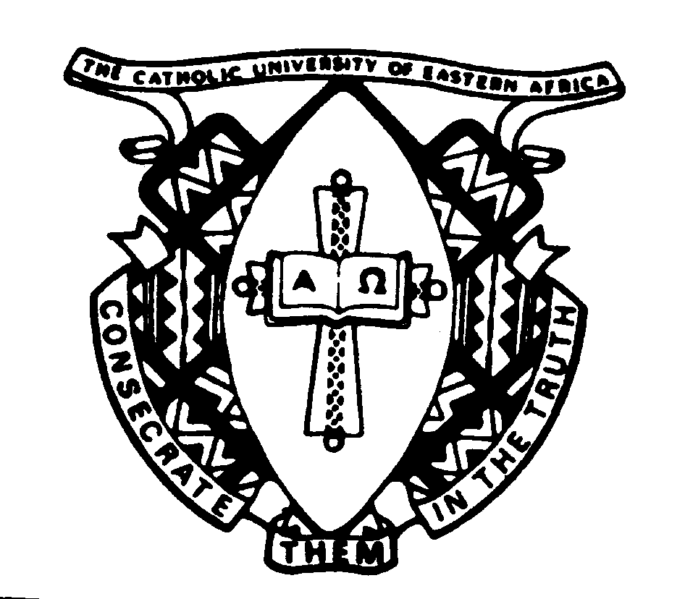
THE CATHOLIC UNIVERSITY OF EASTERN AFRICA
A. M. E. C. E. A
P.O. Box 62157
00200 Nairobi - KENYA
Telephone: 891601-6
Fax: 254-20-891084
E-mail:academics@cuea.edu

MAIN EXAMINATION

AUGUST - DECEMBER 2014 TRIMESTER

FACULTY OF LAW

EVENING PROGRAMME

CLS 417: MEDICAL LAW AND ETHICS

Date: DECEMBER 2014 Duration: 2 Hours
INSTRUCTIONS: Answer Question ONE and ANY OTHER TWO Questions

Q1. Abortion has remained the most emotive issue since the decision in ROE V. WADE and there seems to be no convergent point for the pro-life and pro-choice. The Kenya Constitution of 2010 has not made the issue any less complicated with the definition of life as starting from conception. Therefore discuss abortion from the medi-co-legal and ethical perspectives. (30 marks)

Q2. Write brief notes on the following:

a) Euthanasia (10 marks)
b) Surrogacy (10 marks)

Q3. In SCHLOEDENDORF V. SOCIETY OF NEW YORK HOSPTIAL (1914) Cardozo J. held every human being of adult year and sound mind has a right to determine what shall be done with his own body and to invade a patient’s body without his consent would be an assault. Discuss this statement in the light to consent to treatment.

Q4. The Hippocratic Oath (500BC) provides in part:

“All that may come to my knowledge in the exercise of my profession or in connection with or in daily commerce with men, which ought not to be spoken abroad, I will not diverge abroad and will never review” discuss this statement in relation to the obligation on the doctors to keep information about their patients confidential. (20 marks)

Q5. A mother of three was admitted to a public district hospital in labour where she remained in for 48 hours without delivery mainly because the only doctor who could do a ‘C’ section refused to come. When eventually the doctor came she was taken to theatre, delivered of a very depressed child who breathe after prolong resuscitation, but the mother died on the table. The child is also intellectually handicapped. As an advocate what legal advice will offer to the family of the deceased mother? (20 marks)

*END*

